Regulatory Compliance_MS9932

FCC compliance information statement

Product name: 2.4G Silent Wireless Mouse
Model Number: MS9932
Responsible party: Shenzhen Cudy Technology Co., Ltd.
Address: 7/F, Lepu Tower (West), 66 Xingke Rd, Nanshan, Shenzhen, China
Website: https://www.cudy.com
Tel: +86 755 8600 8993
Email：support@cudy.com
This equipment has been tested and found to comply with the limits for a Class B digital device, pursuant to part 15 of the FCC Rules. These limits are designed to provide reasonable protection against harmful interference in a residential installation. This equipment generates, uses and can radiate radio frequency energy and, if not installed and used in accordance with the instructions, may cause harmful interference to radio communications. However, there is no guarantee that interference will not occur in a particular installation. If this equipment does cause harmful interference to radio or television reception, which can be determined by turning the equipment off and on, the user is encouraged to try to correct the interference by one or more of the following measures:
- Reorient or relocate the receiving antenna.
- Increase the separation between the equipment and receiver.
- Connect the equipment into an outlet on a circuit different from that to which the receiver is connected.
- Consult the dealer or an experienced radio/TV technician for help.

This device complies with part 15 of the FCC Rules. Operation is subject to the following two conditions:
- This device may not cause harmful interference.
- This device must accept any interference received, including interference that may cause undesired operation.

This device complies with FCC radiation exposure limits set forth for an uncontrolled environment and it also complies with Part 15 of the FCC RF Rules.

Caution!
Any changes or modifications not expressly approved by the party responsible for compliance could void the user’s authority to operate the equipment.

Note: The manufacturer is not responsible for any radio or TV interference caused by unauthorized modifications to this equipment. Such modifications could void the user’s authority to operate the equipment.

We, Shenzhen Cudy Technology Co., Ltd., has determined that the equipment shown as above has been shown to comply with the applicable technical standards, FCC part 15. There is no unauthorized change is made to the equipment and the equipment is properly maintained and operated.

CE Mark Warning

This is a class B product. In a domestic environment, this product may cause radio interference, in which case the user may be required to take adequate measures.

Operating Frequency (Maximum transmitted power)
2400 MHz - 2483.5 MHz: 10dBm ± 2dB

EU Declaration of Conformity
Cudy hereby declares that the device is in compliance with the essential requirements and other relevant provisions of Directive 2014/30/EU, Directive 2014/35/EU, Directive 2014/53/EU, Directive 2011/65/EU, Directive (EU) 2015/863.
The original EU Declaration of Conformity can be found at http://www.cudy.com/ce

RF Exposure Information
This device meets the EU requirements (2014/53/EU Article 3.1a) on the limitation of exposure of the general public to electromagnetic fields by way of health protection.

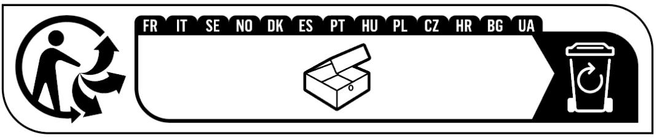

Canadian Statement
This device complies with Industry Canada’s licence‐exempt RSSs. Operation is subject to the following two conditions:
(1) This device may not cause interference; and
(2) This device must accept any interference, including interference that may cause undesired operation of the device.

Le présent appareil est conforme aux CNR d’Industrie Canada applicables aux appareils radio exempts de licence.
L’exploitation est autorisée aux deux conditions suivantes :
(1) l’appareil ne doit pas produire de brouillage;
(2) l’utilisateur de l’appareil doit accepter tout brouillage radioélectrique subi, même si le brouillage est susceptible d’en compromettre le fonctionnement.

Radiation Exposure Statement:
The device meets the exemption from the routine evaluation limits of RSS 102 and compliance with RSS-102 RF exposure, users can obtain Canadian information on RF exposure and compliance.

Le dispositif rencontre l'exemption des limites courantes d'évaluation dans de RSS 102 et la conformité à l'exposition de RSS-102 rf, utilisateurs peut obtenir l'information canadienne sur l'exposition et la conformité de rf.

CAN ICES (B)/NMB(B)





Anatel
Este equipamento não tem direito à proteção contra interferência prejudicial e não pode causar interferência em sistemas devidamente autorizados.
Para maiores informações, consulte o site da ANATEL – www.anatel.gov.br

Safety Information
- Keep the device away from water, fire, humidity or hot environments.
- Do not attempt to disassemble, repair, or modify the device.
- Do not use the device where wireless devices are not allowed.
- This wireless mouse can be powered by batteries that comply with IEC standards.
Please read and follow the above safety information when operating the device. We cannot guarantee that no accidents or damage will occur due to improper use of the device. Please use this product with care and operate at your own risk.

Battery warning
– replacement of a battery with an incorrect type that can defeat a safeguard;
– disposal of a battery into fire or a hot oven, or mechanically crushing or cutting of a battery, that can result in an explosion;
– leaving a battery in an extremely high temperature surrounding environment that can result in an explosion or the leakage of flammable liquid or gas; and
– a battery subjected to extremely low air pressure that may result in an explosion or the leakage of flammable liquid or gas.

Explanations of the symbols on the product label
Note: The product label can be found at the bottom of the product and its I.T.E. power supply. Symbols may vary from products.
Symbol | Explanation
 | Class II equipment
 | Energy efficiency Marking
 | Direct current
 | Polarity of DC power connector
 | For indoor use only
 | Caution
 | Operator’s manual
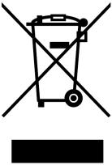 | RECYCLING  This product bears the selective sorting symbol for Waste electrical and electronic equipment (WEEE). This means that this product must be handled pursuant to European directive 2012/19/EU in order to be recycled or dismantled to minimize its impact on the environment. User has the choice to give his product to a competent recycling organization or to the retailer when he buys a new electrical or electronic equipment.
 | Recycling

