Regulatory Compliance_IR04

FCC compliance information statement

Product name: 4G LTE Cat 4 N150 Industrial Router
Model Number: IR02
Component Name | Model
Switching Adapter | A938-120100W-EU1
Responsible party: Shenzhen Cudy Technology Co., Ltd.
Address: 7/F, Lepu Tower (West), 66 Xingke Rd, Nanshan, Shenzhen, China
Website: https://www.cudy.com
Tel: +86 755 8600 8993
Email：support@cudy.com
Note: This equipment has been tested and found to comply with the limits for a Class A digital device, pursuant to part 15 of the FCC Rules. These limits are designed to provide reasonable protection against harmful interference when the equipment is operated in a commercial environment. This equipment generates, uses, and can radiate radio frequency energy and, if not installed and used in accordance with the instruction manual, may cause harmful interference to radio communications. Operation of this equipment in a residential area is likely to cause harmful interference in which case the user will be required to correct the interference at his own expense.

This device complies with part 15 of the FCC Rules. Operation is subject to the following two conditions:
- This device may not cause harmful interference.
- This device must accept any interference received, including interference that may cause undesired operation.

This device complies with FCC radiation exposure limits set forth for an uncontrolled environment and it also complies with Part 15 of the FCC RF Rules.

This equipment must be installed and operated in accordance with provided instructions and the antenna(s) used for this transmitter must be installed to provide a separation distance of at least 20 cm from all persons and must not be co-located or operating in conjunction with any other antenna or transmitter. End-users and installers must be provided with antenna installation instructions and consider removing the no-collocation statement.

Caution!
Any changes or modifications not expressly approved by the party responsible for compliance could void the user’s authority to operate the equipment.

Note: The manufacturer is not responsible for any radio or TV interference caused by unauthorized modifications to this equipment. Such modifications could void the user’s authority to operate the equipment.

We, Shenzhen Cudy Technology Co., Ltd., has determined that the equipment shown as above has been shown to comply with the applicable technical standards, FCC part 15. There is no unauthorized change is made to the equipment and the equipment is properly maintained and operated.

CE Mark Warning

This is a class A product. In a domestic environment, this product may cause radio interference, in which case the user may be required to take adequate measures.

Operating Frequency (Maximum transmitted power)
2400 MHz-2483.5 MHz: 18dBm±2dB
WCDMA:
B1/B5/B8: 24dBm+1.7/-3.7dB
LTE:
B1/B3/B5/B7/B8/B20/B38/B40/B41: 23dBm±2.7dB
B28: 23dBm+2.7/-3.2 dB

EU Declaration of Conformity
Cudy hereby declares that the device is in compliance with the essential requirements and other relevant provisions of Directive 2014/30/EU, Directive 2014/35/EU, Directive 2014/53/EU, Directive 2011/65/EU, Directive (EU) 2015/863 and Regulation (EU) 2019/1782.
The original EU Declaration of Conformity can be found at http://www.cudy.com/ce

RF Exposure Information
This device meets the EU requirements (2014/53/EU Article 3.1a) on the limitation of exposure of the general public to electromagnetic fields by way of health protection.
The device complies with RF specifications when the device is used at 20 cm from your body.

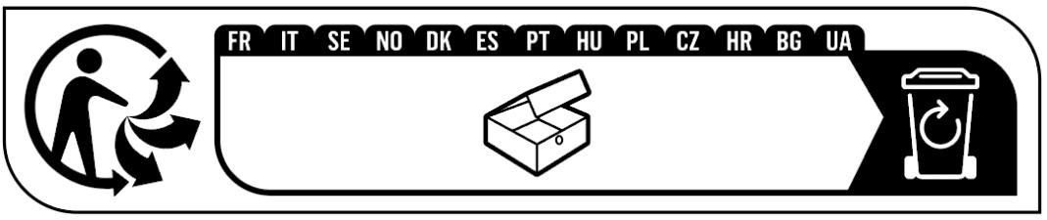

Canadian Statement
This device complies with Industry Canada’s licence‐exempt RSSs. Operation is subject to the following two conditions:
(1) This device may not cause interference; and
(2) This device must accept any interference, including interference that may cause undesired operation of the device.

Le présent appareil est conforme aux CNR d’Industrie Canada applicables aux appareils radio exempts de licence.
L’exploitation est autorisée aux deux conditions suivantes :
(1) l’appareil ne doit pas produire de brouillage;
(2) l’utilisateur de l’appareil doit accepter tout brouillage radioélectrique subi, même si le brouillage est susceptible d’en compromettre le fonctionnement.

Radiation Exposure Statement:
The device meets the exemption from the routine evaluation limits of RSS 102 and compliance with RSS-102 RF exposure, users can obtain Canadian information on RF exposure and compliance.

Le dispositif rencontre l'exemption des limites courantes d'évaluation dans de RSS 102 et la conformité à l'exposition de RSS-102 rf, utilisateurs peut obtenir l'information canadienne sur l'exposition et la conformité de rf.

Colocation and Distance:
This transmitter must not be co-located or operating in conjunction with any other antenna or transmitter.
This equipment should be installed and operated with a minimum distance of 20 centimeters between the radiator and your body.

Cet émetteur ne doit pas être Co‐placé ou ne fonctionnant en même temps qu'aucune autre antenne ou émetteur.
Cet équipement devrait être installé et actionné avec une distance minimum de 20 centimètres entre le radiateur et votre corps.

CAN ICES (A)/NMB(A)





Anatel
Este equipamento não tem direito à proteção contra interferência prejudicial e não pode causar interferência em sistemas devidamente autorizados.
Para maiores informações, consulte o site da ANATEL – www.anatel.gov.br

Safety Information
- Keep the device away from water, fire, humidity or hot environments.
- Do not attempt to disassemble, repair, or modify the device.
- Do not use damaged charger or USB cable to charge the device.
- Do not use any other chargers than those recommended.
- Do not use the device where wireless devices are not allowed.
- Adapter shall be installed near the equipment and shall be easily accessible.
- Operation Temperature: 0° C to +40° C.
- Use only power supplies which are provided by manufacturer and in the original packing of this product. If you have any questions, please don’t hesitate to contact us.
- This product uses radios and other components that emit electromagnetic fields. Electromagnetic fields and magnets may interfere with pacemakers and other implanted medical devices. Always keep the product and its power adapter more than 15 cm (6 inches) away from any pacemakers or other implanted medical devices. If you suspect your product is interfering with your pacemaker or any other implanted medical device, turn off your product and consult your physician for information specific to your medical device.
Please read and follow the above safety information when operating the device. We cannot guarantee that no accidents or damage will occur due to improper use of the device. Please use this product with care and operate at your own risk.

Explanations of the symbols on the product label
Note: The product label can be found at the bottom of the product and its I.T.E. power supply. Symbols may vary from products.
Symbol | Explanation
 | Class II equipment
 | Energy efficiency Marking
 | Direct current
 | Polarity of DC power connector
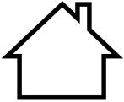 | For indoor use only
 | Caution
 | Operator’s manual
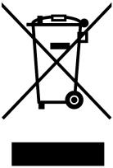 | RECYCLING  This product bears the selective sorting symbol for Waste electrical and electronic equipment (WEEE). This means that this product must be handled pursuant to European directive 2012/19/EU in order to be recycled or dismantled to minimize its impact on the environment. User has the choice to give his product to a competent recycling organization or to the retailer when he buys a new electrical or electronic equipment.
 | Recycling

