Regulatory Compliance_AP3000E Wall

FCC compliance information statement

Product name: AX3000 Wall-Plate Wi-Fi 6 Access Point
Model Number: AP3000E Wall
Responsible party: Shenzhen Cudy Technology Co., Ltd.
Address: 7/F, Lepu Tower (West), 66 Xingke Rd, Nanshan, Shenzhen, China
Website: https://www.cudy.com
Tel: +86 755 8600 8993
Email：support@cudy.com
This device complies with part 15 of the FCC Rules. Operation is subject to the following two conditions:
- This device may not cause harmful interference.
- This device must accept any interference received, including interference that may cause undesired operation.
This device complies with FCC radiation exposure limits set forth for an uncontrolled environment and it also complies with Part 15 of the FCC RF Rules.
This equipment must be installed and operated in accordance with provided instructions and the antenna(s) used for this transmitter must be installed to provide a separation distance of at least 20 cm from all persons and must not be co-located or operating in conjunction with any other antenna or transmitter. End-users and installers must be provided with antenna installation instructions and consider removing the no-collocation statement.
Caution!
Any changes or modifications not expressly approved by the party responsible for compliance could void the user’s authority to operate the equipment.

Note: The manufacturer is not responsible for any radio or TV interference caused by unauthorized modifications to this equipment. Such modifications could void the user’s authority to operate the equipment.

We, Shenzhen Cudy Technology Co., Ltd., has determined that the equipment shown as above has been shown to comply with the applicable technical standards, FCC part 15. There is no unauthorized change is made to the equipment and the equipment is properly maintained and operated.
Issue Date: 2026-1-20

CE Mark Warning

This is a class B product. In a domestic environment, this product may cause radio interference, in which case the user may be required to take adequate measures.

Operating Frequency (Maximum transmitted power)
2400 MHz - 2483.5 MHz: 20dBm
5150 MHz - 5250 MHz: 23dBm
5250 MHz - 5350 MHz: 23dBm
5470 MHz - 5725 MHz: 30dBm

Frequency band 5150 - 5250 MHz:
Indoor use: Inside buildings only. Installations and use inside road vehicles and train carriages are not permitted. Limited outdoor use: If used outdoors, equipment shall not be attached to a fixed installation or to the external body of road vehicles, a fixed infrastructure or a fixed outdoor antenna. Use by unmanned aircraft systems (UAS) is limited to within the 5170 - 5250 MHz band.
Frequency band: 5250 - 5350 MHz:
Indoor use: Inside buildings only. Installations and use in road vehicles, trains and aircraft are not permitted. Outdoor use is not permitted.
Frequency band: 5470 - 5725 MHz:
Installations and use in road vehicles, trains and aircraft and use for unmanned aircraft systems (UAS) are not permitted.

EU Declaration of Conformity
Cudy hereby declares that the device is in compliance with the essential requirements and other relevant provisions of Directive 2014/30/EU, Directive 2014/35/EU, Directive 2014/53/EU, Directive 2011/65/EU, Directive (EU) 2015/863, Directive 2009/125/EC, Directive (EU) 2023/826.
The product was developed under consideration of Directive (EU) 2019/1782.
The original EU Declaration of Conformity can be found at http://www.cudy.com/ce

RF Exposure Information
This device meets the EU requirements (2014/53/EU Article 3.1a) on the limitation of exposure of the general public to electromagnetic fields by way of health protection.
The device complies with RF specifications when the device is used at 20 cm from your body.

National Restrictions
Attention: This device may only be used indoors in all EU member states and EFTA countries, and Northern Ireland.
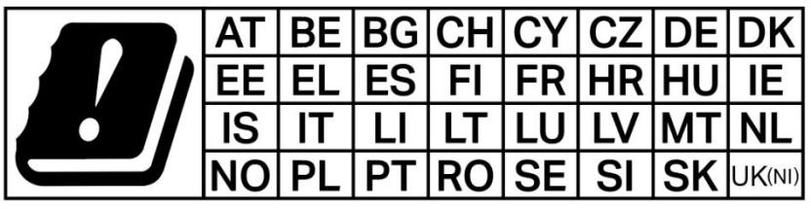

UKCA Mark

Attention: This device may only be used indoors in Great Britain.

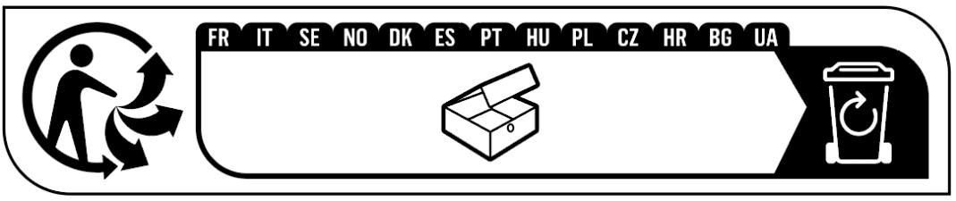

Canadian Statement
This device complies with Industry Canada’s licence‐exempt RSSs. Operation is subject to the following two conditions:
(1) This device may not cause interference; and
(2) This device must accept any interference, including interference that may cause undesired operation of the device.

Le présent appareil est conforme aux CNR d’Industrie Canada applicables aux appareils radio exempts de licence.
L’exploitation est autorisée aux deux conditions suivantes :
(1) l’appareil ne doit pas produire de brouillage;
(2) l’utilisateur de l’appareil doit accepter tout brouillage radioélectrique subi, même si le brouillage est susceptible d’en compromettre le fonctionnement.

Radiation Exposure Statement:
The device meets the exemption from the routine evaluation limits of RSS 102 and compliance with RSS-102 RF exposure, users can obtain Canadian information on RF exposure and compliance.
Le dispositif rencontre l'exemption des limites courantes d'évaluation dans de RSS 102 et la conformité à l'exposition de RSS-102 rf, utilisateurs peut obtenir l'information canadienne sur l'exposition et la conformité de rf.

Caution:
The device for operation in the band 5150–5250 MHz is only for indoor use to reduce the potential for harmful interference to co-channel mobile satellite systems.
Les dispositifs fonctionnant dans la bande 5150-5250 MHz sont réservés uniquement pour une utilisation à l’intérieur afin de réduire les risques de brouillage préjudiciable aux systèmes de satellites mobiles utilisant les mêmes canaux;

Colocation and Distance:
This transmitter must not be co-located or operating in conjunction with any other antenna or transmitter.
This equipment should be installed and operated with a minimum distance of 20 centimeters between the radiator and your body.

Cet émetteur ne doit pas être Co‐placé ou ne fonctionnant en même temps qu'aucune autre antenne ou émetteur.
Cet équipement devrait être installé et actionné avec une distance minimum de 20 centimètres entre le radiateur et votre corps.

Industry Canada Statement
CAN ICES (B)/NMB(B)


Продукт сертифіковано згідно с правилами системи УкрСЕПРО на відповідність вимогам нормативних документів та вимогам, що передбачені чинними законодавчими актами України.



Anatel
Este equipamento não tem direito à proteção contra interferência prejudicial e não pode causar interferência em sistemas devidamente autorizados.
Para maiores informações, consulte o site da ANATEL – www.anatel.gov.br

Safety Information
- Keep the device away from water, fire, humidity or hot environments.
- Do not attempt to disassemble, repair, or modify the device.
- Do not use damaged charger or USB cable to charge the device.
- Do not use any other chargers than those recommended.
- Do not use the device where wireless devices are not allowed.
- Adapter shall be installed near the equipment and shall be easily accessible.
- Operation Temperature: 0° C to +40° C.
- Use only power supplies which are provided by manufacturer and in the original packing of this product. If you have any questions, please don’t hesitate to contact us.
- This product uses radios and other components that emit electromagnetic fields. Electromagnetic fields and magnets may interfere with pacemakers and other implanted medical devices. Always keep the product and its power adapter more than 15 cm (6 inches) away from any pacemakers or other implanted medical devices. If you suspect your product is interfering with your pacemaker or any other implanted medical device, turn off your product and consult your physician for information specific to your medical device.
Please read and follow the above safety information when operating the device. We cannot guarantee that no accidents or damage will occur due to improper use of the device. Please use this product with care and operate at your own risk.

Explanations of the symbols on the product label
Note: The product label can be found at the bottom of the product and its I.T.E. power supply. Symbols may vary from products.
Symbol | Explanation
 | Class II equipment
 | Energy efficiency Marking
 | Direct current
 | Polarity of DC power connector
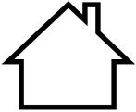 | For indoor use only
 | Caution
 | Operator’s manual
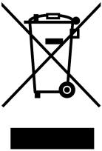 | RECYCLING  This product bears the selective sorting symbol for Waste electrical and electronic equipment (WEEE). This means that this product must be handled pursuant to European directive 2012/19/EU in order to be recycled or dismantled to minimize its impact on the environment. User has the choice to give his product to a competent recycling organization or to the retailer when he buys a new electrical or electronic equipment.
 | Recycling

